Optimization of decolorization and COD removal from textile wastewater using Electro Fenton process with Ti/IrO₂ electrodes

N. D. D. Duc ^{1,2)}, N. T. A. Thu *²⁾, P. T. Nghia*², N. T. Phong^{*1)}
1) Ho Chi Minh City University of Technology, Vietnam
2) Ho Chi Minh City University of Food Industry, Vietnam
*ntphong@hcmut.edu.vn
Keywords: Electro Fenton; textile wastewater; synthetic dye; Box Benhken.
Introduction
The wastewater from dyes and dye manufacturing industry causes serious impact on natural water bodies and land in the surrounding area. This wastewater contains high organic loading and may have the presence of toxic or presence of bio-recalcitrant compounds, hence the application of biological treatment is not feasible (Azbar 2004). The structure of dye molecules is generally complex and stable to heat and light. Furthermore, synthetic dyes usually contain aromatic rings which are harmful and non-biodegradable.
The drawbacks of traditional physico-chemical processes are related to cost and the generation of large volume of sludge (Ahmad 2010). On the other hand, advanced oxidation processes (AOPs) offer effective and rapid alternative treatments for various persistent contaminants until their overall mineralization, base on the in situ generation of hydroxyl radicals (Marco Panizza et al. 2011).
There are various electrode materials and IrO₂ is known as a high conducting, lifelong metal oxide. To the best of our knowledge, the optimization of decolorization and COD removal from real textile wastewater using Electro Fenton (EF) process with Ti/IrO₂ electrodes has not reported previously. The aim of this study was to achieve optimal operating condition of three parameters, including the amount of Fe²⁺ used, initial COD and applied current density for the efficiency of COD and color removal from real textile wastewater.
Material and Methods
Wastewater Sampling: Wastewater was collected from the equalization tank of THANHCONG textile garment investment trading joint stock company wastewater treatment plan. The textile wastewater was pre-treated by coagulation/flocculation method with FeCl₃ 1% w/w in order to eliminate Total suspended solid (TSS).
Materials and Apparatus:K₂CrO₇ (Merck, Germany), FeSO₄.7H₂O (Merck, Germany), and Fe(NH₄)₂(SO₄)₂.6H₂O (Merck, Germany) were purchased to analyze COD. An UV–VIS spectrometer was used to measure color of the wastewater. pH was measured using a pH meter (WTW Inolab 7110, Germany).

The reactor (Fig. 1) was made by a 500ml glass beaker. Electrodes were connected to the current power supply (MATRIX MPS-3005S). The distance between electrodes was kept 2 cm in all experiments. The air was pumped at 1 l_{air}/l_{sample}/min near the cathode and Fe²⁺ was added at different concentrations for each experiment. Magnetic stirring was used to avoid concentration gradients. Before and after each experiment, the electrodes were washed properly using HCl acid solution followed by distilled water. Electro Fenton was then performed for 30 min under differential dosages of Fe²⁺, and H₂SO₄ which were adjusted for each set experiment. Next, the pH of solution was adjusted to 7 using 1N NaOH and water sample was taken to centrifuge. The supernatant was then taken for COD and color analyses.
Response Surface Analysis: Experimental designs were made by using Modde 5.0 (Umetrics, Umea, Sweden). Based on Box -Behnken Design, 15 experiments were designed for 3 factors at three levels, included current density (x₁; 20, 30, 40 mA/cm²), initial COD (x₂; 320, 480, 640 mg/l), and Fe²⁺ concentration (x₃; 6, 10, 14 mMol).
Results and Conclusions
Second-order Polynomial Equation: An empirical relationship expressed by a second-order polynomial equation was fitted between the experimental and input variables, as shown in following equations:
Y₁ = 93.31- 3.1225x₁ – 1.66667x₂ -8.60249x₁x₁ – 6.37416x₂x₂ – 6.93583x₃x₃ + 1.25x₂x₃; R² = 0.939 R²_{adj} = 0.923, p value (regression)= 0.000, p value (lack of fit) = 0.415.
Y₂ = 98.2667 – 0.459165x₂ + 0.312092x₃ – 1.15041 x₁x₁ – 0.922908x₂x₂ – 0.723744x₃x₃ + 0.276667x₁x₂ – 0.542503x₁x₃ – 0.621668x₂x₃; R² = 0.912, R²_{adj} = 0.890, p value (regression) = 0.000, p value (lack of fit) = 0.528.
Determination and Application of Optimum Condition of Treatment: Application of Modde 5.0 provided us the minimal point which represented the optimum condition for the treatment, as can be seen from Fig. 2. Accordingly, the optimal condition was at J = 28.9 mA/cm², CODin = 449.5 mg/l, Fe²⁺ concentration of 10.7 mMol. Operating at this condition resulted in the predicted efficiency of color and COD removal of 98.3 % and 93.5 %, respectively.
Conclusions: The Electro Fenton process with Ti/IrO₂ electrodes was successfully optimized for decolorization and COD removal from real textile wastewater using Response surface methodology – Box Behnken design. The regression polynomial equations were formulated for the relations between variables (Fe²⁺ concentration, initial COD concentration , applied current density) and responses (efficiency of color and COD removal) with coefficient of determination (R²) value of 0.939 (for Y₁) and 0.912 (for Y₂). At Fe²⁺ concentration of 28.9 mMol, initial COD of 449.5 mg/l and applied current density of 28.9 mA/cm², the treatment system reached its optimum operating condition, resulted in the predicted color output of 12.3 Pt-Co and COD output of 29.1 mg/l. Extended discussion about the effect of Fe²⁺ concentration, pH and voltage on color and COD removal was given based on the results from the developed model. Finally, the results from this study confirmed that Electro Fenton process is a promising solution to treat textile wastewater since the color and COD effluent from this process met well the national standard, QCVN 13:2015/BTNMT.

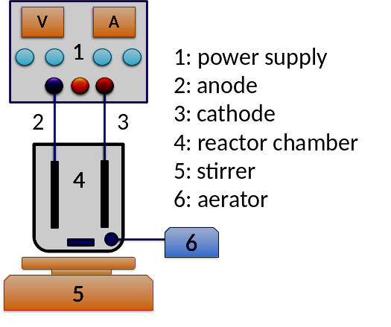
Figure 1. schema of the reactor
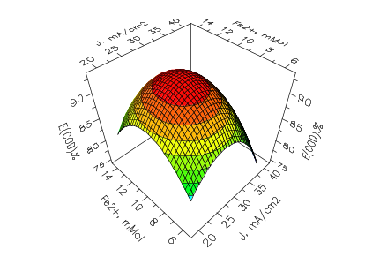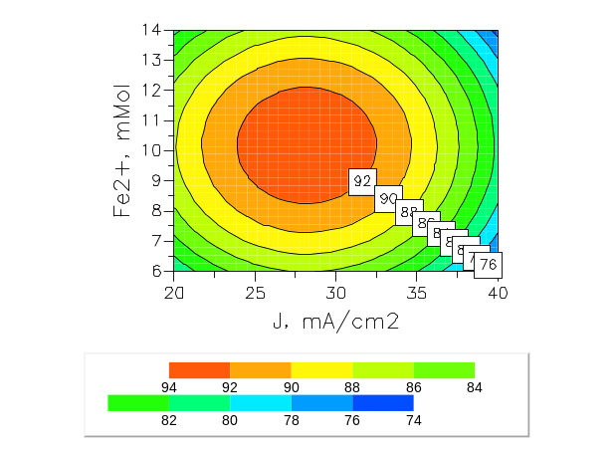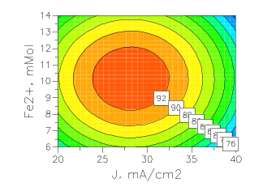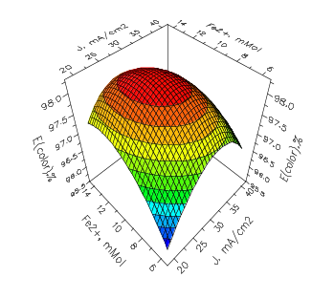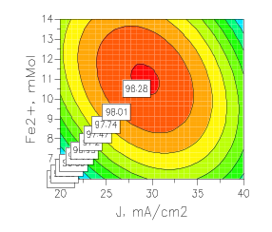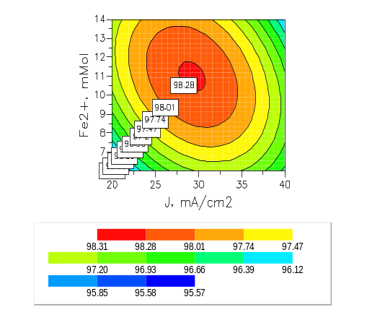
a. COD removal efficiency plots | b. Color removal efficiency plots

Figure 2. Contour plots of removal efficiency at CODin of 480 mg/l
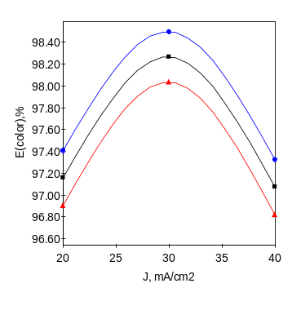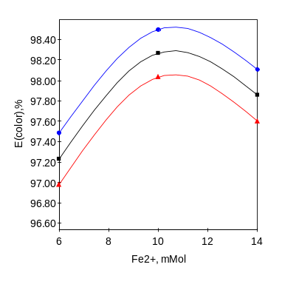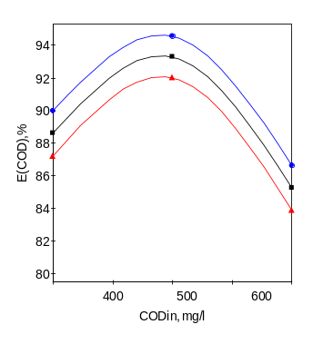
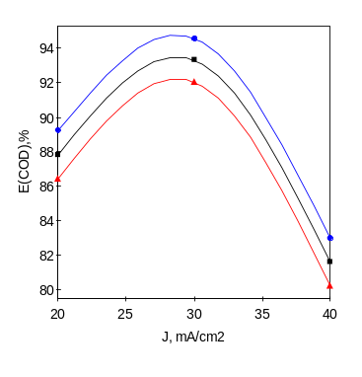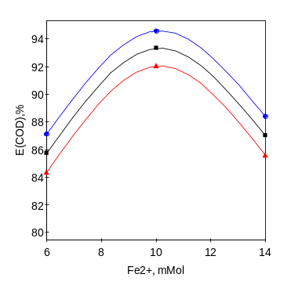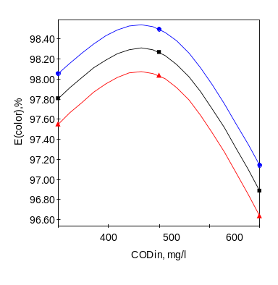
- Color | - Upper confident interval | - Lower confident interval
Figure 3. Prediction plots of variables to color removal efficiency

References
Ahmad A (2010), Effect of preparation conditions of activated carbon from bamboo waste for real textile wastewater. Journal of Hazardous Materials 173,487-493
Azbar N (2004), Comparison of various advanced oxidation processes and chemical treatment methods for COD and color removal from a polyester and acetate fiber dyeing effluent. Chemosphere 55,35-43
Marco Panizza, Mahdi Asadi and Amir Hossein Mahvi (2011), Evaluation of Electro-Fenton Process Performance for COD andReactive Blue 19 Removal from Aqueous Solution. Iranian Journal of Health and Environment 5(4)

